**Technical Exercise – Commercial Sales Analyst**

**A Comprehensive Analysis and Insights**

**Introduction:**

I was provided with two datasets: The payment plan table and the sales table. The main objective of this technical exercise is to analyze the data and create a dashboard to answer specific questions.

The Payment Plan and Sales data contain valuable information about sales generated from various product categories, models, payment plans and more. In this analysis, I explore the data to uncover insights into sales trends, revenue generation and the performance of different product types, models and brands.

**Methodology:**

My strong python and pandas skills enabled me perform data preparation, cleaning, and exploratory analysis to ready the data for querying in MySQL Work bench and dashboard design in Excel. I then designed two informative and visually appealing dashboards in Excel to present the key findings. And lastly, I leveraged SQL workbench tools to query and analyze data directly from a database, providing further insights to support decision-making processes.

**Analysis, Insights and Recommendations:**

My analysis below revealed significant trends and patterns in the data, providing valuable insights for decision-making. These insights can inform strategic actions and drive improved outcomes.

**The Payment Plan Table:**

The payment plan table had 488 rows and 18 columns. The dataset also had missing values in the variant, model, Deposit, Daily Top Up, Loan Duration and Total Top Ups columns which I was able to handle by utilizing my data wrangling skills to ensure consistency in the dataset as shown in the attached Payment Plan Exploratory Data Analysis pdf template.

After cleaning the Dataset, I further performed Exploratory Analysis to gain further insights such as the distribution of payment plan status, the most popular Product Type, Product Category, Sub category and more as shown below.

Throughout my exploratory analysis, I was able to gain the following insights from different columns in the dataset;

* 93.65% of the payment plans were closed with only 6.15% still active.

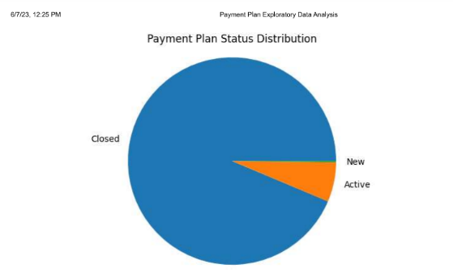

* MK TV is the most popular Product category and M-KOPA 6000 is the most popular Sub Category

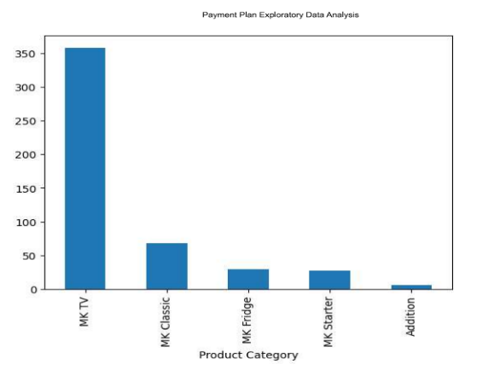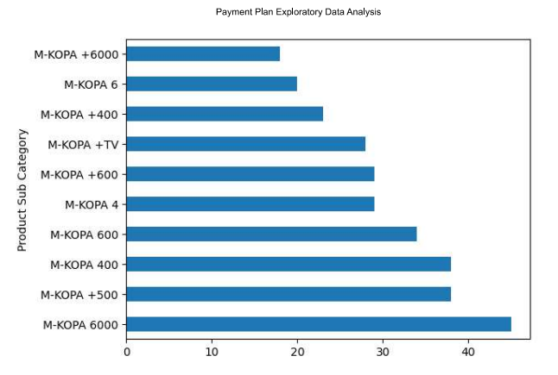

Many more insights on the data set were gained but in regards to the above insights, data-driven decisions can be made to optimize product strategy, capitalize on popular categories and sub categories as well as align offerings with customer preferences. This in return can lead to increased sales and growth.

**The Sales Table:**

The sales table on the other hand had 194 rows and 4 columns namely Model, Local Sold At Month, Payment Plan Name and Sales. The table had null values and an outlier which I was able to handle by getting rid of the entire row with missing values and the outlier as shown below.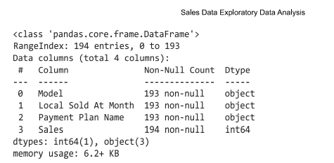

After cleaning the data and ensuring its consistency, I merged the Sales and Payment Plan tables to perform further analysis. By using pandas in Jupyter, I combined the two tables based on the common columns 'Payment Plan Name' and 'Model', resulting in a merged sales dataset with 154 rows.

This merged dataset allows for ad hoc analysis to address the specific requirements of the questions at hand.

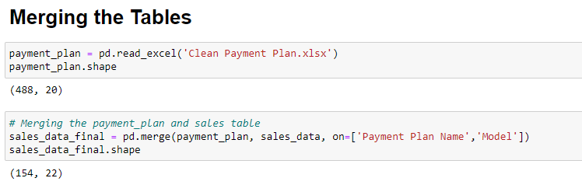

After the merge, I selected relevant columns that were necessarily needed to answer questions on the sales table. Further, I created a new column for Revenue which was calculated by finding the product of the Daily Top Up and Sales columns.

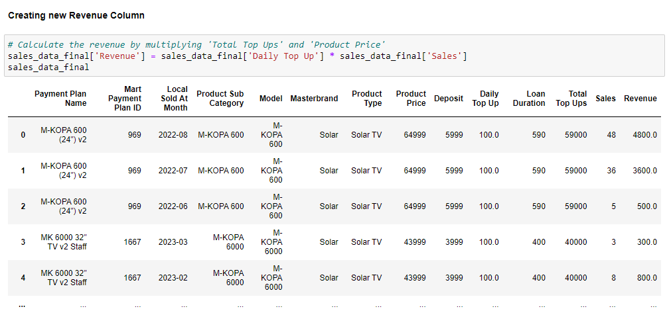

**Implications:**

Besides the outlier and missing values in the sales table, I noticed in the sales table that there was some data entry error in regards to the M-KOPA +500 model where its product price was 1. This can lead to inaccurate calculations of revenue, misleading sales trends, and distorted insights, hence impacting decision-making and potentially causing financial losses.

**Conclusion:**

In this comprehensive analysis, I have explored and gained valuable insights from the Payment Plan and Sales datasets. By leveraging my skills in Python, pandas, MySQL Workbench, and Excel, I was able to perform data preparation, cleaning, exploratory analysis, dashboard design, and querying to extract meaningful information and support decision-making processes.

This analysis provided valuable insights into sales trends, revenue generation, and the performance of different product categories, subcategories, models, and payment plans. The findings can guide strategic decision-making, optimize product strategies, and align marketing efforts to drive sales growth, improve customer satisfaction, and maximize profitability.

For more insights, I have attached pdf templates for the entire data cleaning, preparation and exploratory analysis processes in python for both the Payment Plan and Sales Table, an SQL query file with answers to the specific questions and Excel workbooks displaying the required dashboard designs.